Query to categorize products based on their price:

SELECT

ProductID,

ProductName,

Price,

CASE

WHEN Price < 50 THEN 'Low'

WHEN Price BETWEEN 50 AND 200 THEN 'Medium'

ELSE 'High'

END AS PriceCategory

FROM dbo.products;

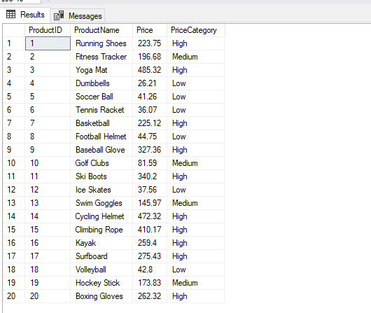

Query to join customers table with geography table to enrich customer data with geographic information:

SELECT

c.CustomerID,

c.CustomerName,

c.Email,

c.Gender,

c.Age,

g.Country,

g.City

FROM dbo.customers AS c

LEFT JOIN

dbo.geography AS g

ON

c.GeographyID = g.GeographyID

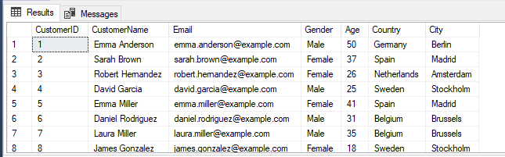

Query to clean whitespace issue in the ReviewText column:

SELECT

ReviewID,

CustomerID,

ProductID,

ReviewDate,

Rating,

REPLACE (ReviewText, ' ', ' ') AS ReviewText

FROM dbo.customer_reviews

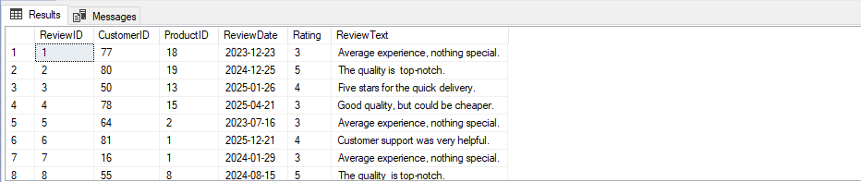

Query to clean and normalize the engagement_data table:

SELECT

EngagementID,

ContentID,

CampaignID,

ProductID,

UPPER(REPLACE(ContentType, 'Socialmedia', 'Social Media')) AS ContentType,

LEFT(ViewsClicksCombined, CHARINDEX('-', ViewsClicksCombined) - 1) AS Views,

RIGHT(ViewsClicksCombined, LEN(ViewsClicksCombined) - CHARINDEX('-', ViewsClicksCombined)) AS Clicks,

Likes,

FORMAT(CONVERT(DATE, EngagementDate, 103), 'dd-MM-yyyy') AS EngagementDate

FROM dbo.engagement_data

WHERE

ContentType != 'Newsletter';

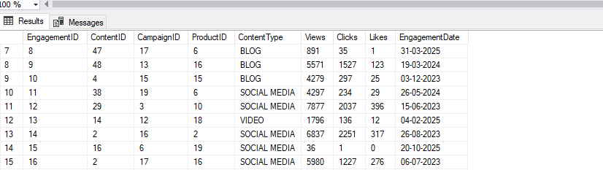

Query to identify and tag duplicate records and a subquery to clean and process data :

WITH DuplicateRecords AS (

SELECT

JourneyID,

CustomerID,

ProductID,

VisitDate,

Stage,

Action,

Duration,

ROW_NUMBER() OVER (

PARTITION BY CustomerID, ProductID, VisitDate, Stage, Action

ORDER BY JourneyID

) AS row_num

FROM

dbo.customer_journey

)

SELECT *

FROM DuplicateRecords

ORDER BY JourneyID

SELECT

JourneyID,

CustomerID,

ProductID,

VisitDate,

Stage,

Action,

COALESCE(Duration, avg_duration) AS Duration

FROM

(

SELECT

JourneyID,

CustomerID,

ProductID,

VisitDate,

UPPER(Stage) AS Stage,

Action,

Duration,

AVG(Duration) OVER (PARTITION BY VisitDate) AS avg_duration,

ROW_NUMBER() OVER (

PARTITION BY CustomerID, ProductID, VisitDate, UPPER(Stage), Action

ORDER BY JourneyID

) AS row_num

FROM

dbo.customer_journey

) AS subquery

WHERE

row_num = 1;

